Department of Land and Natural Resources
Land Division, Oahu District Land Office

- Background:
Oahu District Land Office (“ODLO”) received a complaint for State lands described below regarding concerns caused a tree near residential property and next to the State owned portion of Makiki Ditch system. ODLO is seeking solicitation for bids through the State Procurement Office website (“HiePro”) for removal and trimming of the trees.

Successful contractor is responsible to furnish licensing documents, materials, equipment, and permit to perform the work described below, and further subject to terms and conditions contained herein.

- Property Description:
State land identified as tax map key (1) 2-4-029:067, along the apartment building at 1631 Liholiho St. See map attached as Exhibits A-1.

- Scope of Work:
Three (3) trees to be completely removed. Trees are numbered in the photos, tree #2 cut stump to six (6) foot height to match the fence height, and trees #1 and #3 stump no higher than one (1) foot tall. See exhibits B-1 to B-4. All stumps to be treated with systemic herbicide with a dye marker to kill the stump. All cut branches and debris must be removed and disposed off-site at an authorized facility.

**NOTE: Before tree trimming/tree removal ensure there are no white terns (manu-o-Kū) present. In 2024 tree #2 had a white tern raising a hatchling. Current nesting status is unknown. If tern present, contact ODLO staff.

- General Notes:
- During the duration of the project, there shall be one (1) qualified arborist certified by the International Society of Arboriculture (ISA Certified Arborist) supervising the job.
- All work to be done during the hours of 8:00AM to 4:30PM, Monday -Friday. Exceptions can be request in writing to ODLO, but will not be effective unless approved.
- Work may not proceed without an authorized Notice to Proceed (“NTP”) letter/email or purchase order from the ODLO.
- The Contractor shall be responsible for verifying the location of all utilities and structures. Any damage, injury, and/or loss to any property resulting from the performance of the work shall be the sole responsibility of the Contractor and shall be remedied promptly by the Contractor at his own expense.
- The Contractor will be provided contact information for the sites to coordinate physical access to the site, if needed.
- The Contractor shall provide safety signs, barricade, and other devices necessary for the safety and convenience of the general public.
- The Contractor shall observe all applicable Federal, State, and Municipal acts, statutes, ordinance, and rules pertaining to the performance of this job.
- The bid award shall be based on the availability of funds.
- Submission of bid shall be the evidence that the Contractor understands the scope of the job described herein.

- Term of Contract:
The Contractor shall commence the work within two (2) weeks from the email sent by ODLO notifying the approval of the purchase order for the job.

The Contractor shall complete the job described herein to the satisfaction of ODLO within five (5) calendar weeks of the commencement date described above.

- Completion of Work
The Contractor shall notify ODLO by email, within three (3) days upon completion of the job described herein, to coordinate a site inspection for job quality and compliance with contract.

- Liability Insurance:
Prior to commencement of work, the Contractor shall furnish a copy of the general liability insurance policy or policies with liability limits as outlined below. Award of contract is contingent upon compliance of the following condition. The neighboring private property may also request liability coverage for this job, Fasone Properties LLC, as additional insured.
The Contractor shall procure and maintain, at its own cost and expense, in full force and effect throughout the life of this contract, general liability insurance, or its equivalent, with an insurance company or companies licensed or authorized to do business in the State of Hawaii with an AM Best rating of not less than “A- VIII” or other comparable and equivalent industry rating, in an amount of at least $1,000,000 for each occurrence and $2,000,000 aggregate, and with coverage terms acceptable to the Chairperson of the Board. The policy or policies of insurance shall name the State of Hawaii as an additional insured.

In addition, the Contractor shall provide automobile liability insurance in an amount not less than $1,000,000 combined single limit per occurrence.

Each insurance policy required by this contract, including a subcontractor's policy, shall contain the following clauses:

1. "The State of Hawaii is added as an additional insured as respects to operations performed for the State of Hawaii."
2. "It is agreed that any insurance maintained by the State of Hawaii will apply in excess of, and not contribute with, insurance provided by this policy."

- Hawaii Compliance Express:
Pursuant to §3-122-112 Responsibility of offeror, as proof of compliance with the requirements of section 103D-310(c), HRS, Contractor compliance will be conducted via Hawaii Compliance Express (HCE). If the valid HCE certification is not available one (1) week after the close of the bid this will disqualify the bid. It is the responsibility of the Contractor to ensure they are registered with HCE and their information is updated and accurate.

- Re-Execution of Work:
The contractor shall re-execute any work that fails to conform to the requirements of the contract and shall immediately remedy any defects due to faulty workmanship by the Contractor. Should the Contractor fail to comply, the State reserves the right to engage the services of another company to perform the services and to deduct such costs from monies due to the Contractor.

- Liquidated Damages:
Liquidated damages are fixed at the sum of ONE HUNDRED DOLLARS ($100.00) per each and every calendar day the Contractor fails to perform in whole or in part any of his obligations specified herein. Liquidated damages, if assessed, may be deducted from any payments due or to become due to the Contractor.

- Indemnification and Defense:
The Contractor shall release, indemnify, defend, and hold harmless the State of Hawaii, its officers, agents, and employees from and against all liability, loss, damage, costs, and expense including attorney’s fees, and all claims, suits, and demands therefore, arising out of or resulting from the acts or omissions of the CONTRACTOR or the CONTRACTOR’S employees, agents, officers, under this Contract. The provisions of this paragraph shall remain in full force and effect notwithstanding the expiration or early termination of this Contract. The purchase of liability insurance shall not relieve the Contractor of the obligations described herein.

- Contact Information:
For the purpose of this Contract, Darlene Bryant-Takamatsu, of Oahu District Land Office, or designee, is the staff member overseeing this Contract, who can be reached at (808) 587-0447 or email at darlene.bryant@hawaii.

TMK (1) 2-4-029:067 Exhibit A-1
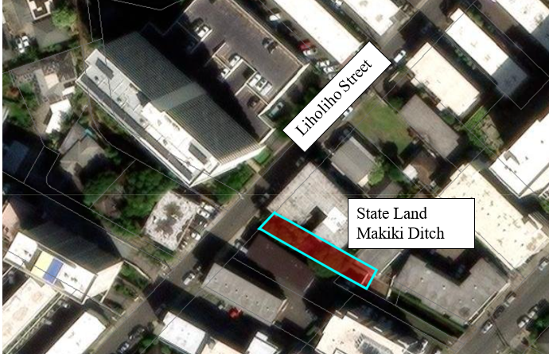

Exhibit B-1 Trees to Remove
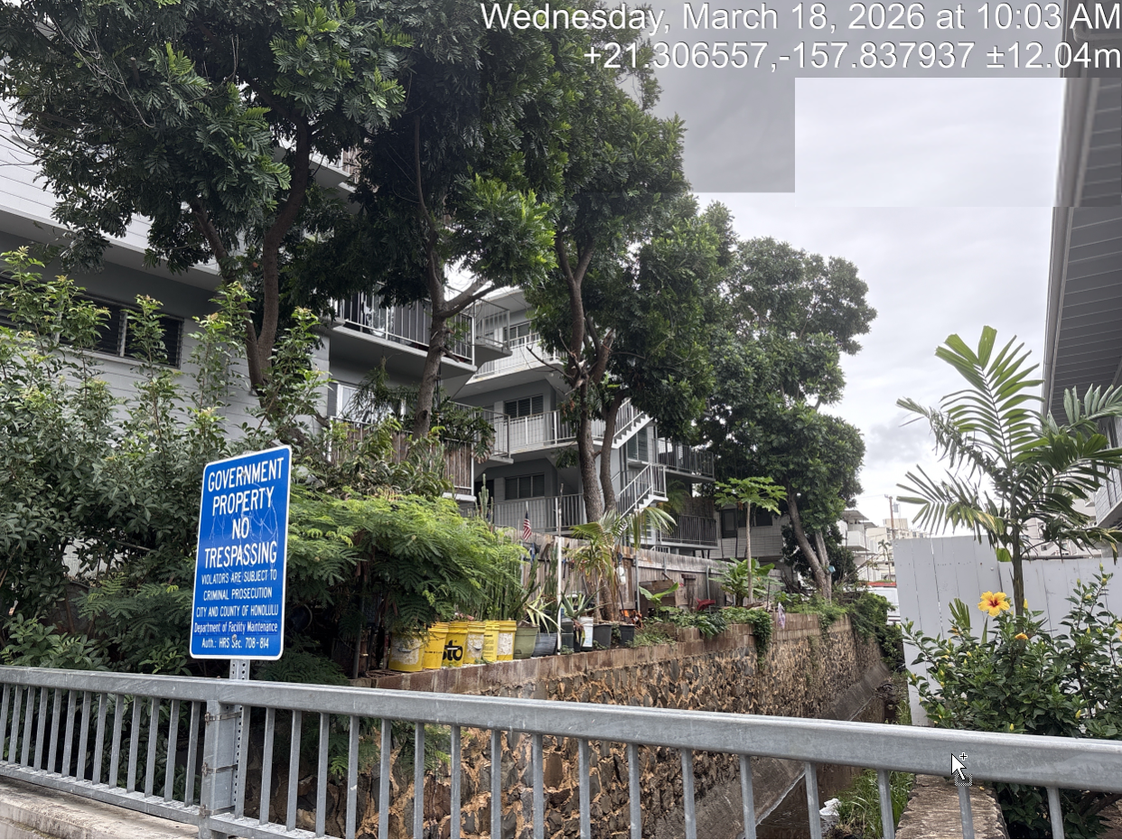
1
3
2

Exhibit B-2 Tree #1 to Remove

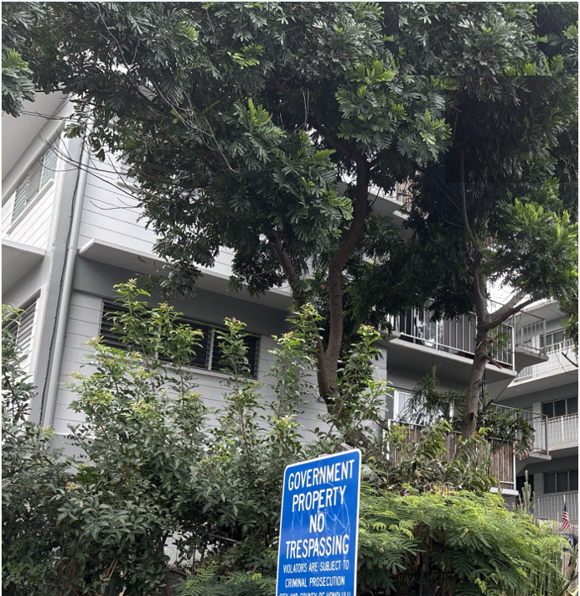
#1

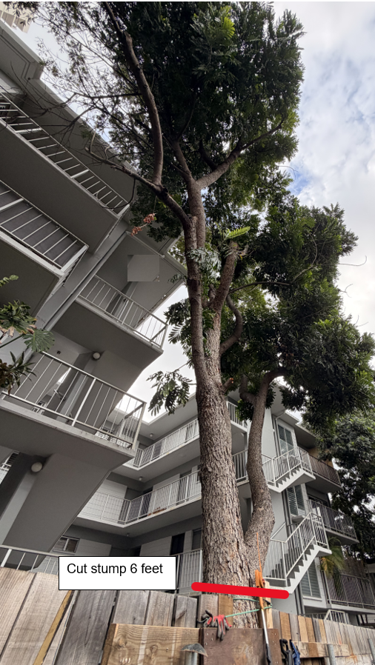
Exhibit B-3 Tree #2 to Remove
#2
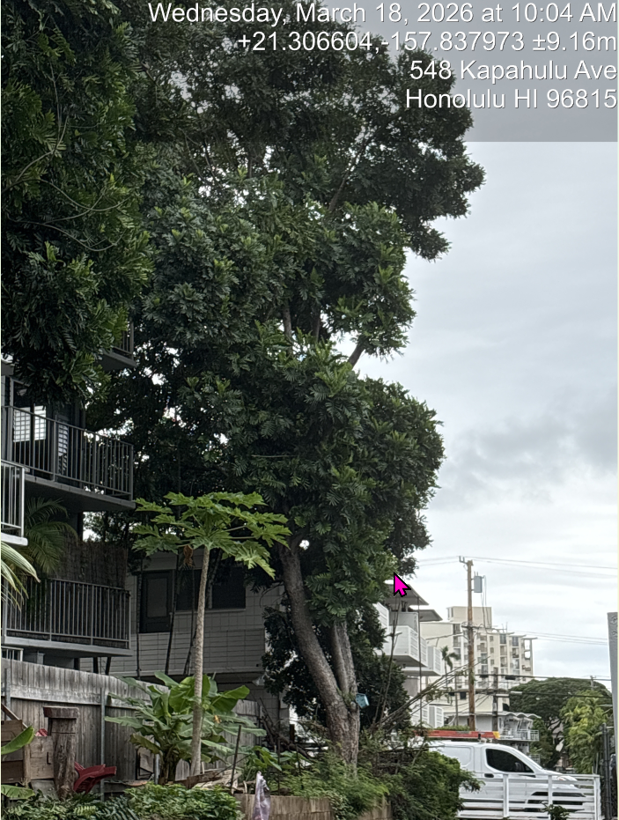
Exhibit B-4 Tree #3 to Remove
#3

